**Installation and User Manual**

**Requirements**

**Server**:

- PHP 5.3 or higher (Recent stable build recommended)

- MySQL 5 or higher

- KU-SPMS can be run on LAMP (Linux, Apache, MySQL, PHP), WAMP (Windows, Apache, MySQL, PHP)and XAMPP ( , Apache, MySQL, PHP, Perl) servers.

It has been tested on all servers and it is recommended to use LAMP servers.

**Client**:

- Firefox 3, Internet Explorer 7/8, Opera 9, Safari

- Javascript enabled

**Installation instructions**

This installation instruction manual is for localhost servers like XAMPP, WAMP and LAMP.

1. Upload KU-SPMS and PHPMailer_5.2.0 folder into your server.
2. Create a new MySQL database for KU-SPMS.

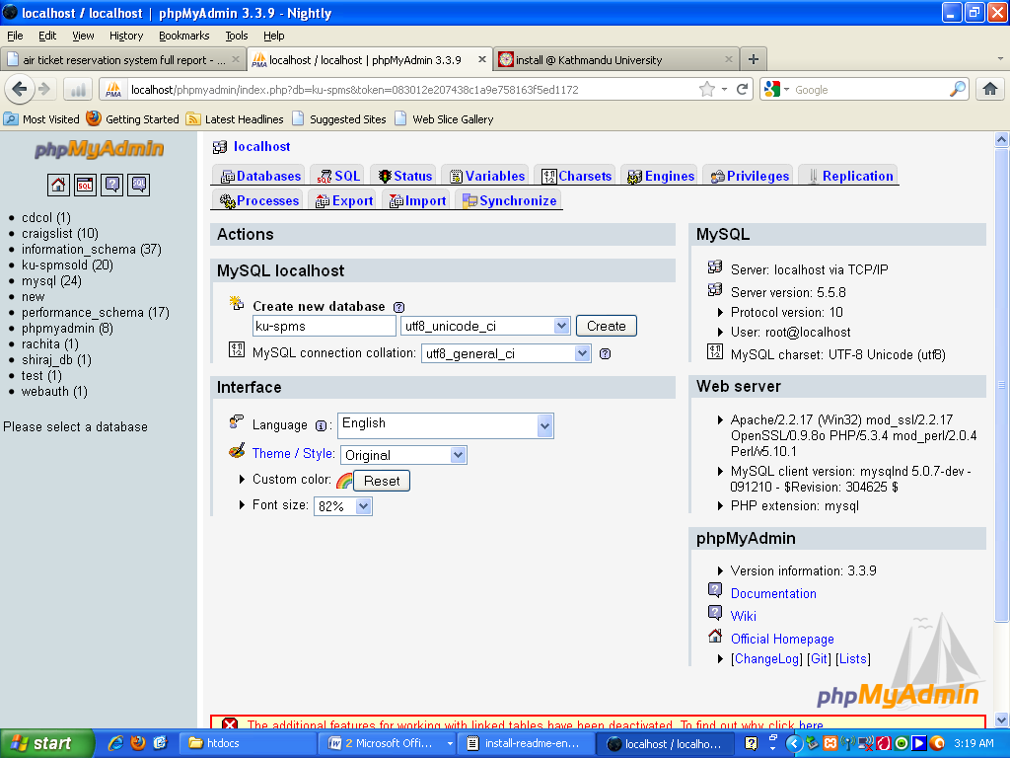

Fig 6.1 database creation for KU-SPMS

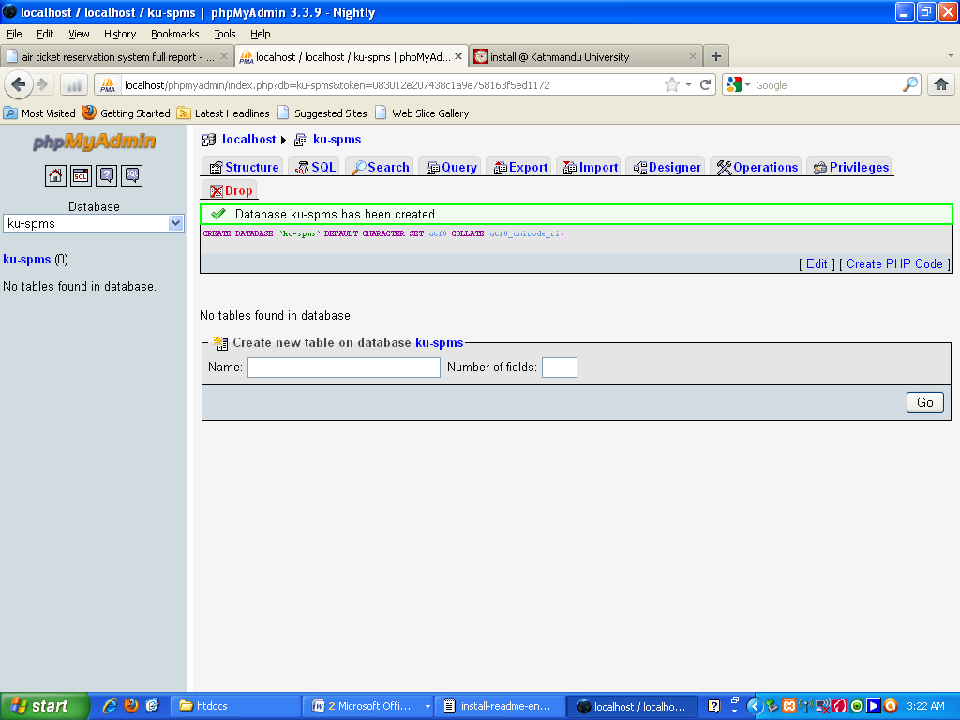

Fig 6.2 database created for KU-SPMS

1. Point your browser to install.php and follow the instructions given. The screen shots are given below.

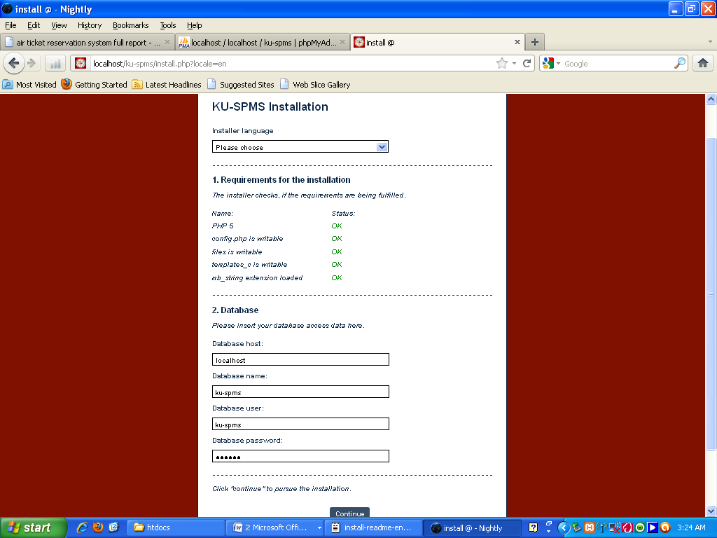

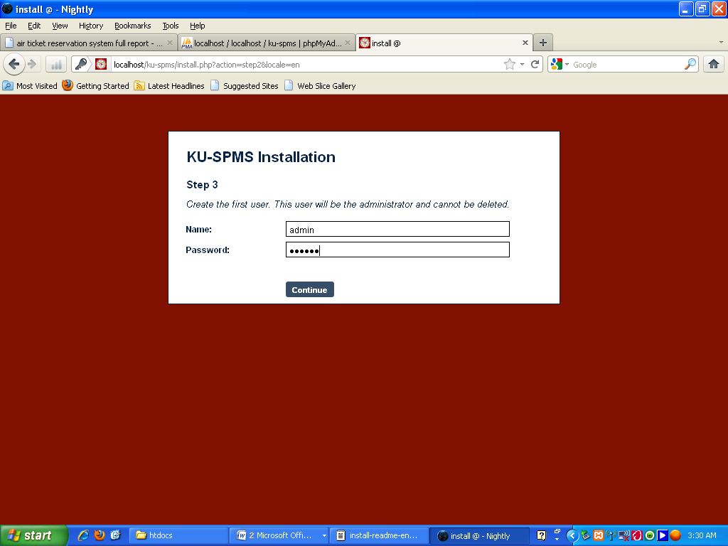

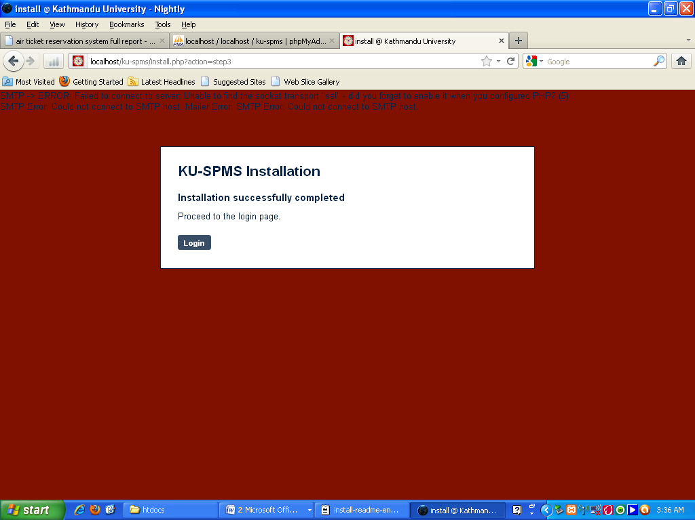

Fig 6.3 required steps for installation of KU-SPMS

**User Manual**

Users can’t create their account so they have to apply to administration to create account and after successful creation of user account either student or supervisor can log in. The log in page looks as give below.

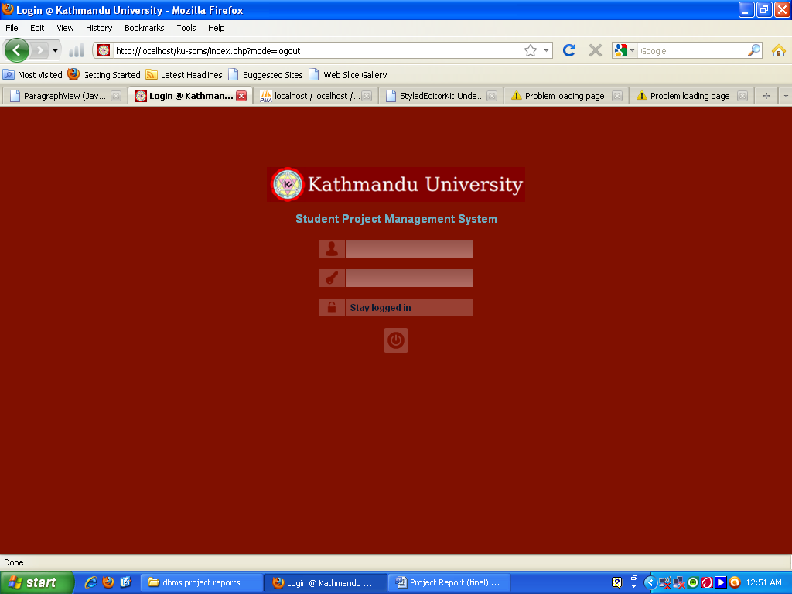

Fig 6.4 log in page of KU-SPMS

After successful authentication, users are taken to their respective pages where they can see all the assigned projects, tasks, files uploaded, messages sent and received, daily logs and activities, calendar and deadlines, closed projects’ grades and many more.

**Desktop**

The first page after log page is the desktop page. The screenshot is provided below. In this page user can see brief information of projects, tasks, messages and calendar (if it’s the first time then the page would only contain calendar and my projects information). The search and chat option appear in every page visited.

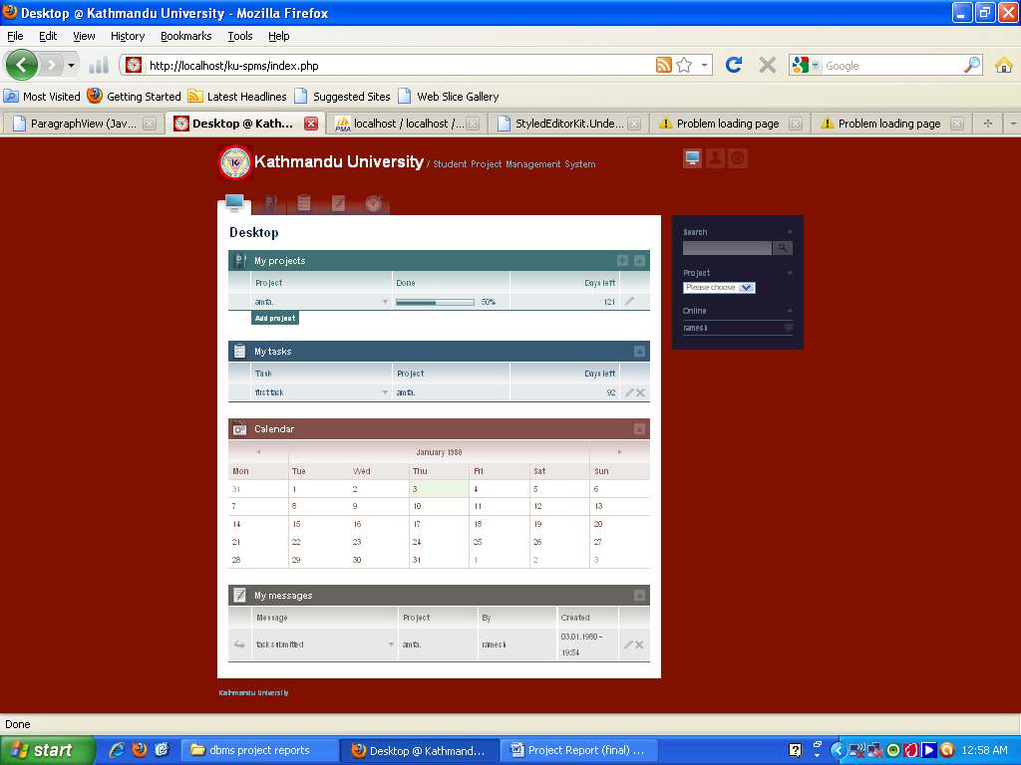

Fig 6.5 Desktop page of KU-SPMS

**My projects**

This is the second tab menu. This section contains information about the opened projects and their progress, closed projects and option to add projects. The screenshot is given below.

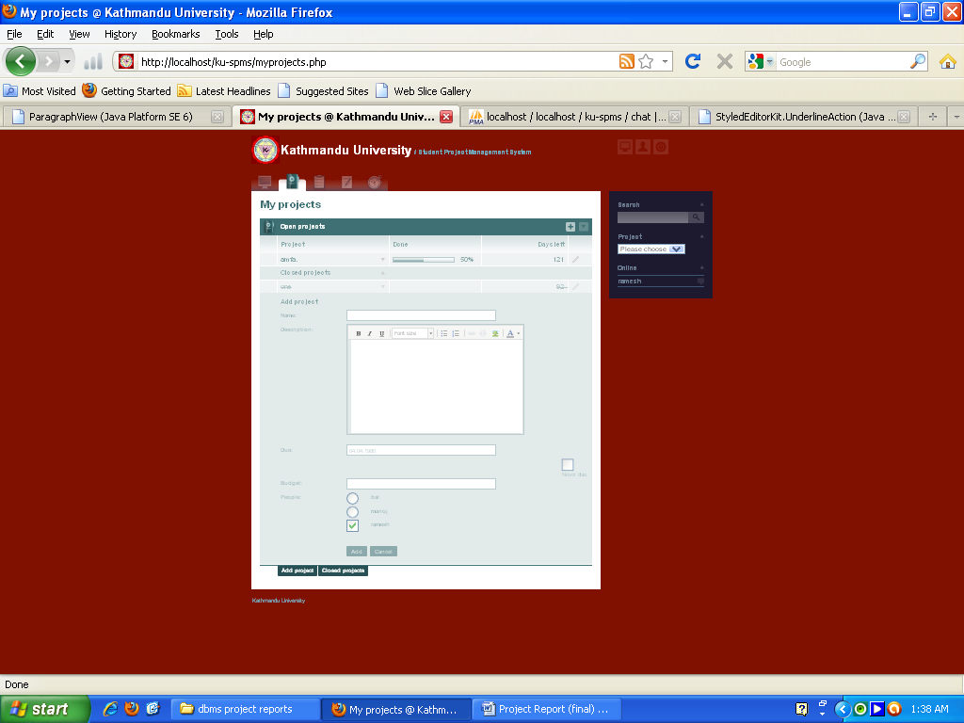

Fig 6.6 Project page with add project and closed project options of KU-SPMS

For each project, we can edit, close and open the projects, create milestones, task-lists and tasks for the project, send messages, upload files and folders and add and edit grades of the project. Students are not authorized to use some of the options mentioned above. Some screenshots are provided below.

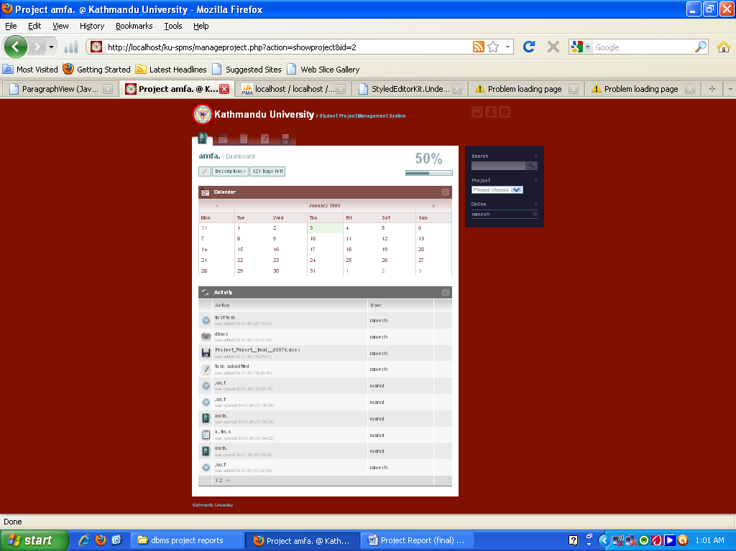

Fig 6.7 Project page of KU-SPMS

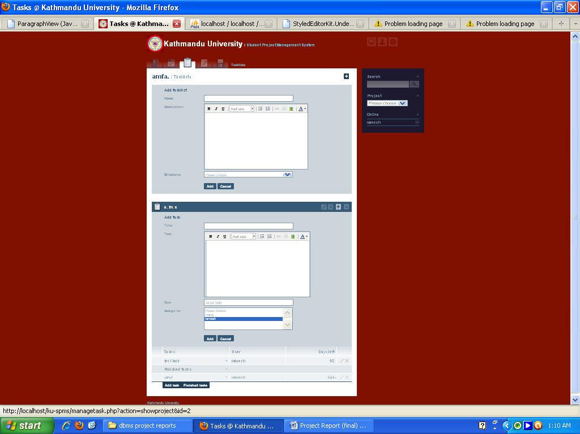

Fig 6.8 Tasklist page with add tasklist and add task option of KU-SPMS

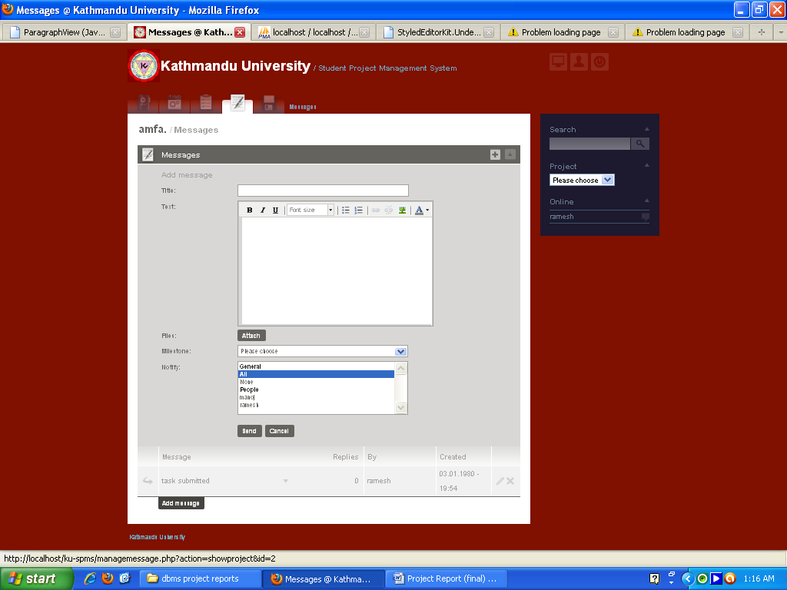

Fig 6.9 Messages page with add message option of KU-SPMS

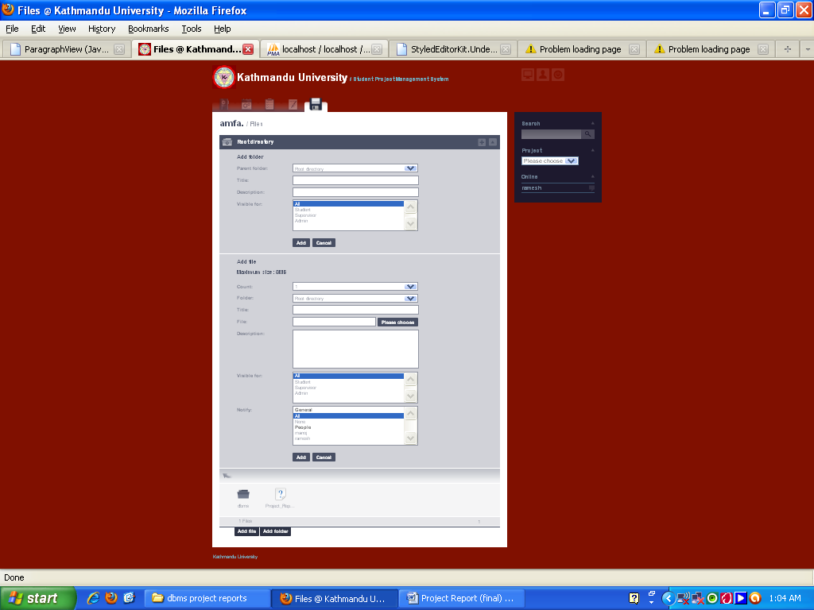

Fig 6.10 Files page with add files and add folder option of KU-SPMS

**My tasks**

This is the third tab-menu. It contains information about all the pending and finished tasks. The screenshot is given below.

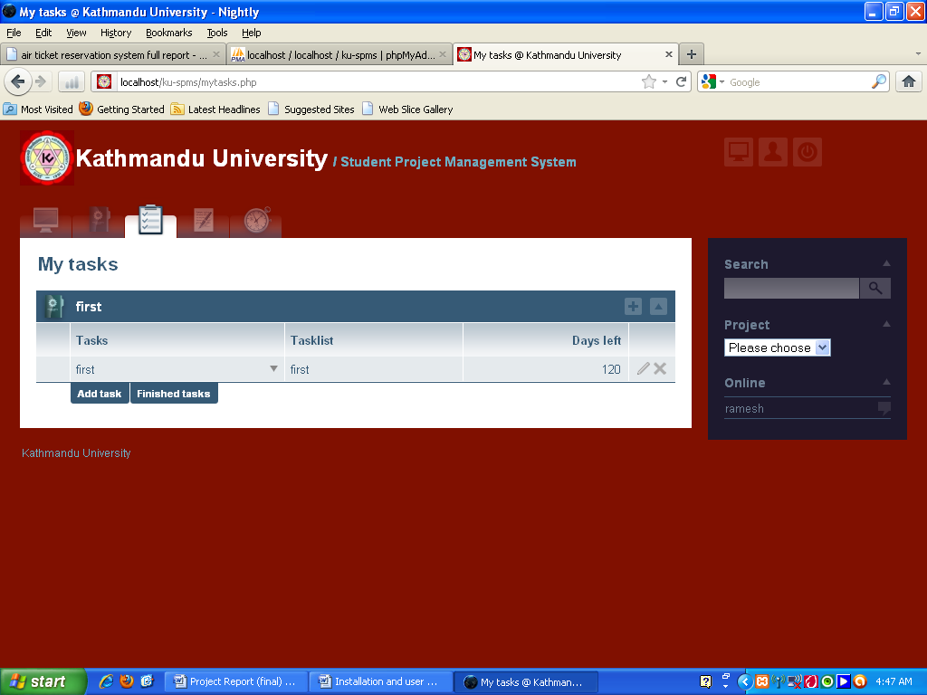

Fig 6.11 My tasks page of KU-SPMS

**My messages**

This is the fourth tab-menu. It contains all the information about the messages received and sent. The screenshot is given below for clarity.

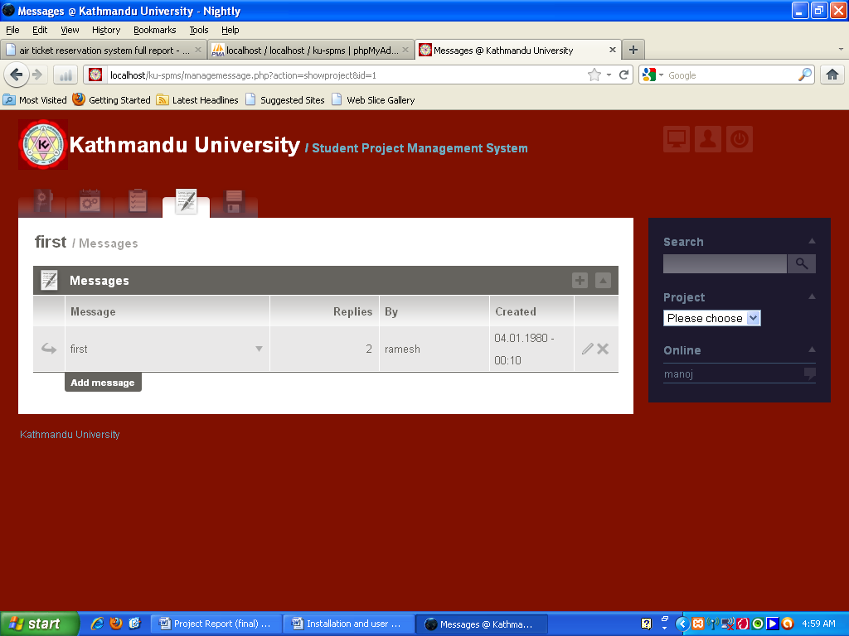

Fig 6.12 My messages page of KU-SPMS

**My grades**

This is the forth tab-menu under Desktop. It displays all the grades of closed(finished) projects. The screenshot is given below.

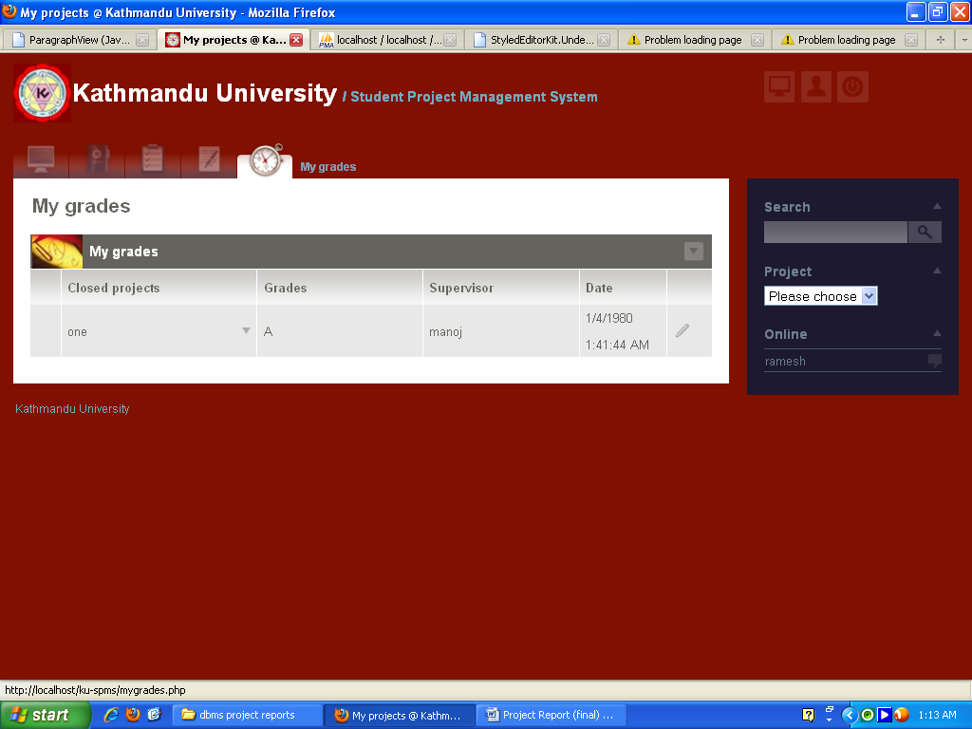

Fig 6.13 My grades page of KU-SPMS

**Chat and search**

Users can chat with online users and search files, projects, users and other stuffs associated with projects.

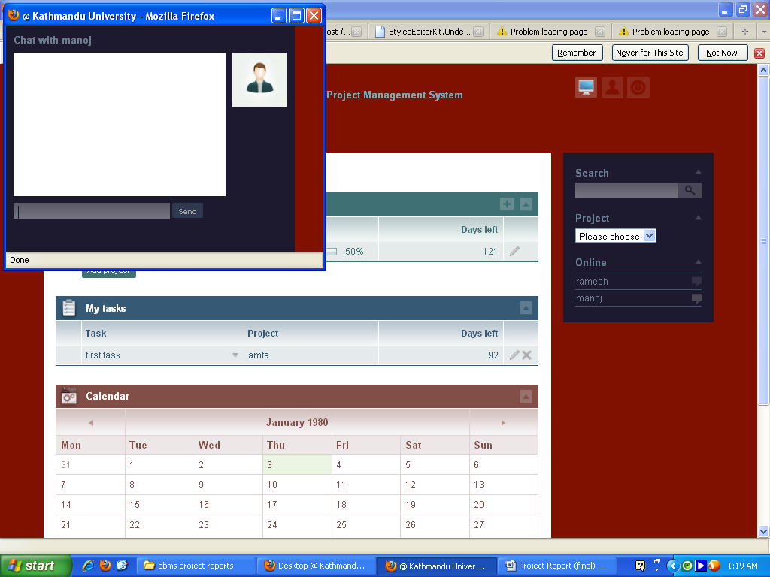

Fig 6.14 Chatting page of KU-SPMS

**My account**

My account section contains information about the user and the user can edit and update all the details as well. The screenshot is as given below.

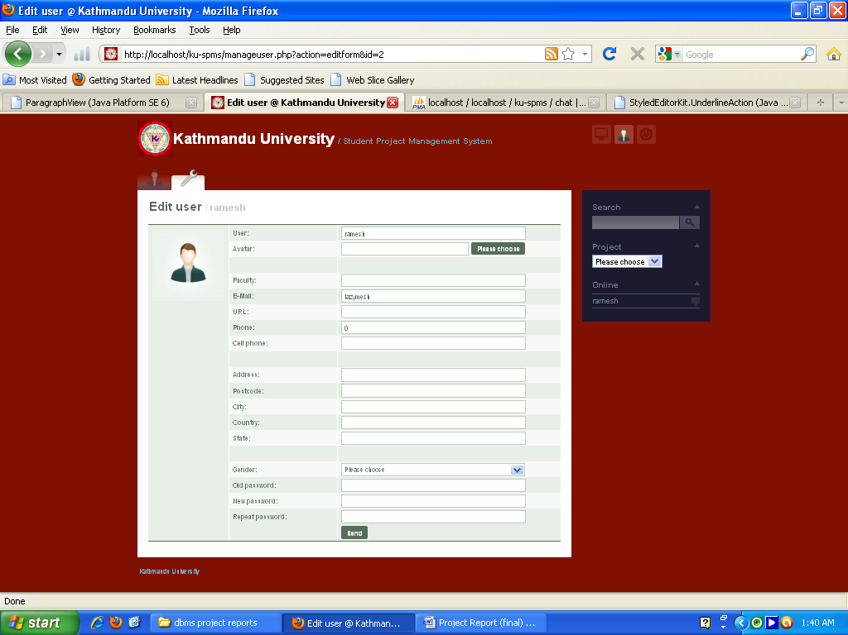

Fig 6.15 Edit user page of KU-SPMS

**NOTE: email is sent to associated users about the updates and changes in the projects and account.**